Leprosy

Post-Exposure Prophylaxis
with
Single-Dose Rifampicin

Field Guide

How to adapt this field guide
Before use, adapt the field guide to your country specific situation. Look at the colored text and adapt it accordingly:
- Selection: «i», «ii», «iii» etc., choose the appropriate (delete the others)
- Addition: «__», insert the appropriate number/word
- Suggestion/comment: can be deleted if not appropriate for a setting

Background and overview

Leprosy and Mycobacterium leprae transmission
- Leprosy is an infectious disease caused by Mycobacterium leprae.
- Early case detection, diagnosis and treatment have been the key to halt transmission and avoid disability.
- Studies have shown that people with close and prolonged contact to a patient with active leprosy, i.e. “contacts”, are at increased risk of developing the disease.

Leprosy post-exposure prophylaxis using single dose rifampicin
- The overall aim is to reduce the risk of developing leprosy through post-exposure prophylaxis (PEP).
- The core strategy is the tracing of contacts of leprosy patients, and the administration of a single dose of rifampicin (SDR) to contacts with no signs or symptoms for neither leprosy nor TB and fulfilling other specific inclusion criteria.
- The effectiveness of this concept has been tested in clinical trials and was piloted in several countries across Africa, Asia and Latin America for its feasibility and impact.

Key activities of SDR-PEP
- Index patient identification
- Contact tracing
- Contact screening
- Administration of SDR to consenting contacts without leprosy symptoms or other exclusion criteria (pregnancy, under age, tuberculosis etc.)

Effectiveness of SDR-PEP
- PEP using SDR has shown to reduce the risk for contacts of leprosy patients to developing clinical leprosy in the first two years by 57% [1].
- Since 2018, the WHO global leprosy guidelines recommend PEP using SDR for the prevention of leprosy [2].

Feasibility and impact of SDR-PEP
- SDR-PEP is used as national policy in Cuba (2002), Peru (planned for end 2016), Morocco (2014) and Samoa (2016), but documentation and publication on these pilots are scarce [3]
- LPEP was piloted in 8 leprosy endemic countries in Asia, South America and Africa [4].
- Preliminary results show, “PEP with SDR is safe; can be integrated into the routines of different leprosy control programmes; and is generally well accepted by index patients, their contacts and the health workforce. The program has also invigorated local leprosy control [5].”

Operational guide to PEP with SDR in ____
- Location: i-region ____, ii-district ____, iii-national
- Contact definition: i-household, ii-neighbor, iii-social contacts
- Overall roles, responsibilities and timelines (next page).

Overall roles, responsibilities and timelines
Responsible person | Task
_____(name/position) | Index patient enrolment
_____(name/position) | Listing of contacts
_____(name/position) | Transfer of contact list to contact tracer
_____(name/position) | Contact tracing
_____(name/position) | Contact screening
_____(name/position) | Final diagnosis of suspected contacts
_____(name/position) | Follow-up of contacts with negative outcome at referral
_____(name/position) | SDR administration to eligible contacts (including side effects)
_____(name/position) | SDR stock management
_____(name/position) | Data entry
_____(name/position) | Document printing and distribution

Key timelines
- Minimal delay between index patient start of MDT and contact tracing: __ weeks
- Maximum time/number of attempts to trace contacts not present upon first visit: __ month
- Reporting to district level (in alignment with general reporting requirements): every __ weeks

Enrolment of index patient

Procedure for identification of index patient:
Newly diagnosed leprosy patients (i.e. index patients) are identified by i-clinician, ii-other trained medical staff (e.g. nurse/midwife), iii-lay health workers (e.g. community health volunteer, paramedical worker) iv-other (specify) at the start of MDT treatment. The index patient agrees to disclose his/her leprosy status to contacts and provides informed consent (if needed). While contacts residing in the catchment area of the leprosy control program can be traced by its own staff, special attention is required in border areas to facilitate the tracing of contacts residing outside the health region.

Data collection:
Following enrolment, the i-clinician, ii-other trained medical staff (e.g. nurse/midwife), iii-lay health workers (e.g. community health volunteer, paramedical worker) iv-other (specify) collects data on the index patient and creates a contact list (see 8. Data Recording and Reporting).

Initiation of contact tracing:
Following enrolment of the index patient, the responsible health worker informs the responsible for contact tracing about the new leprosy patient and instructs them to trace the listed contacts. Single dose rifampicin administration must not be earlier than __ weeks post start of MDT of the index patient.

Responsibilities
i-physician, ii-nurse, iii-health worker/PHC staff, iv-dermatologist, v-other (specify):
- Instructing responsible clinic staff to contact/inform new leprosy patient
- Determination of eligibility of index patient (i.e. having contacts, resident of the area (if locally applicable)
- Recruitment (informed consent (if needed)) of index patient

Recording
- Index patient data (see 8. Data Recording and Reporting)

Tracing and enrolment of contacts

Person responsible for contact tracing and enrolment:
Contacts of eligible leprosy patients are traced and enrolled by i-clinician, ii-other trained medical staff (e.g. nurse/midwife), iii-lay health workers (e.g. community health volunteer, paramedical worker) iv-other (specify).

Frequency of contact tracing:
The frequency of contact tracing activities depends on the number of new leprosy patients over a period of time in the catchment area (e.g. once every month). __ attempts (phone calls, visits etc.) to trace contacts are made within __ months.

Procedures for tracing and enrolment of contacts:
- i-clinician, ii-other trained medical staff (e.g. nurse/midwife), iii-lay health workers (e.g. community health volunteer, paramedical worker) iv-other (specify) in charge of contact tracing is informed about newly enrolled index patients by i-clinician, ii-other trained medical staff (e.g. nurse/midwife), iii-lay health workers (e.g. community health volunteer, paramedical worker) iv-other (specify) and receives the list of contacts established with the help of the index patient.
- Upon reaching the index patients household and surroundings (for neighbor and social contacts), or the agreed meeting point, the completeness of the list of contacts is verified, and the list is updated if needed (e.g. additional contacts are listed). Contacts are marked “absent” if they cannot be traced. If appropriate, a follow-up on absent contacts is done.

Contact definition:
- The context specific definition of a contact can be defined accordingly: A contact is a resident in the same household, and/or neighborhood, and/or social environment as the index patient for more than __ months.

Essential information for contacts about screening and SDR administration:
- Benefits of SDR (reduced risk of developing leprosy disease but no full protection or further prophylactic effect!)
- Screening procedures: physical examination of whole body (privacy is respected, examiner of the same gender).
- Meaning of possible outcomes
  - No sign of leprosy disease: SDR administration if no other exclusion criteria (under age, pregnancy, TB etc.) are met.
  - Sign of leprosy disease: referral for diagnosis confirmation (if applicable). If the diagnosis is confirmed, initiation of MDT for leprosy
- Administration (single dose, capsules/syrup for children, dose according to age/weight, no follow-up visits or examinations needed).
- Potential adverse events (flu-like syndrome, jaundice) or side effects (colorization of the urine).
- Contact to inform in case of adverse events, to receive care.

Responsibilities
i-clinician, ii-other trained medical staff (e.g. nurse/midwife), iii-lay health workers (e.g. community health volunteer, paramedical worker) iv-other (specify):
- Tracing contacts of leprosy patients no earlier than __ weeks post diagnosis
- Inform contact tracer about index patients and his/her contacts are to be traced
- Determine eligibility of contacts for screening
- Enrolment of contacts: provide information about procedures: evidence of SDR (reduction in risk to develop clinical leprosy), screening procedures, SDR administration or referral to final diagnosis or MDT-treatment.

Recording
- List contacts
- Verify exclusion criteria

Screening of contacts

Procedures for screening of contacts:
- Respect privacy!
- Screening should be done by i-clinician, ii-other trained medical staff (e.g. nurse/midwife), iii-lay health workers (e.g. community health volunteer, paramedical worker) iv-other (specify) of the same gender
- Screening location must be protected from outside views/interference
- Sufficient space
- Good lighting (preferably natural light but not necessarily direct sunlight)
- Adequate time (allow at least 10-15 minutes per contact)
- Examine the skin for patches, from head to toe and on the front of the body as well as the back.
- Ask if the contact noticed unusual spots/patches and/or unusual sensations in their hands or feet.
- Patches can appear as pale or reddish areas with a raised edge.
- Test the feeling in the skin patches. Ask the person to close their eyes. Lightly touch the skin patches with cotton wool or a pointed object and ask the person to point the spot where you touched them.
- Examination of nerves
- Do slit skin smear and skin biopsy and histopathology examination if required

How to recognise some major leprosy symptoms:
Training and ability to recognize leprosy is a pre-requisite for the implementation of SDR-PEP and essential for the contact tracers. The national leprosy program is responsible to train and refresh their contact tracers and leprosy expert to detect signs and symptoms. However in a system where suspected leprosy patients can be referred for final diagnosis the least knowledge of signs and symptoms for referral are:
- Pale or reddish patches on the skin
- Loss, or decrease, of feeling in the skin patch
- Numbness or tingling of the hands or feet
- Weakness of the hands, feet or eyelids
- Painful or tender nerves
- Swellings or lumps (often in the face or earlobes)
- Painless wounds or burns on the hands or feet
- Loss of eyebrows or eyelashes

Screening outcomes and follow-up:
- No sign of leprosy disease: see guide 7. Administration of SDR to Eligible Contacts. If patient is found to have a skin disease other than leprosy in the screening process, either treatment is provided or a referral to a corresponding clinician is made
- Sign of leprosy disease: referral to i-clinic, ii-hospital, iii-health center, iv-leprosy expert, v-dermatologist, vi-clinician, vii-other (specify) for final diagnosis, fill out referral form/register (if confirmation not done on site), see 6.Referral and examination

Responsibilities
i-clinician, ii-other trained medical staff (e.g. nurse/midwife), iii-lay health workers (e.g. community health volunteer, paramedical worker) iv-other (specify):
- Screening of contacts
- Refer contacts with suspected signs of leprosy or TB to the corresponding specialist

Recording
- Record screening outcome (see 8. Data Recording and Reporting)
- Refer contacts with suspected sign of leprosy or TB

Referral and Examination of contacts with suspected leprosy and/or TB

A referral is only needed, if the expert to diagnose new leprosy patients is not present at the screening of the contact!

Person responsible for referring suspected cases:
Contacts with suspected leprosy and/or TB are referred by i-clinician, ii-other trained medical staff (e.g. nurse/midwife), iii-lay health workers (e.g. community health volunteer, paramedical worker) iv-other (specify).

Person responsible for examining referred contacts:
Contacts with suspected leprosy or TB are referred (if diagnosis cannot be confirmed on spot) and re-examined in/by the leprosy or TB expert at i-clinic, ii-hospital, iii-health center, iv-dermatology unit, vii-other (specify).

Procedures for referral and examination of suspected leprosy/TB patients among contacts:
- Refer all contacts with signs of leprosy and/or TB to the responsible person/facility (specify).
- The referred contacts are examined by the responsible clinician to confirm or rule out leprosy or TB.
- Contacts with a negative diagnosis outcome are assessed for SDR eligibility and offered SDR as applicable (see 7. Administration of SDR).
- Contacts whose disease status is confirmed are put on treatment as applicable (TB, leprosy).

Responsibilities
i-clinician, ii-other trained medical staff (e.g. nurse/midwife), iii-lay health workers (e.g. community health volunteer, paramedical worker) iv-other (specify):
- Referral of contacts with suspected signs of leprosy and/or TB
- Assessment of SDR eligibility of negative contacts, i.e. contacts that have been back-referred
- SDR administration to eligible back-referred contacts

Leprosy/TB Expert:
- Examination of referred contacts suspected to have leprosy/TB (if not done on spot).
- Confirmed diagnosis: Initiation of leprosy or TB treatment as per the standard procedures of the national program
- Back-refer contacts with negative diagnosis outcome to the contact tracer team for SDR-PEP (if not done on spot)

Recording
- i-clinician, ii-other trained medical staff (e.g. nurse/midwife), iii-lay health workers (e.g. community health volunteer, paramedical worker) iv-other (specify) records contact information (inclusion and exclusion criteria) for negative and therefore eligible contacts

Administration of SDR to eligible contacts

Person responsible for administering SDR:
- i-clinician, ii-other trained medical staff (e.g. nurse/midwife), iii-lay health workers (e.g. community health volunteer, paramedical worker) iv-other (specify) to contacts with negative screening outcome
- i-clinician, ii-other trained medical staff (e.g. nurse/midwife), iii-lay health workers (e.g. community health volunteer, paramedical worker) iv-other (specify) follows-up final diagnosis of referred contacts, to identify contacts with suspected leprosy/TB but negative follow-up examination.

Procedures for SDR administration:
- Assess SDR eligibility (see below)
- Inform contact about eventual adverse events of SDR intake
- Record all information in the contacts data sheet
- Administer correct dose (see below) of SDR ideally on an empty stomach
- Directly observe drug intake
- Advise the contact whom to inform if they experiences any adverse events (e.g. flu-like symptoms, yellow eyes)

Eligibility for SDR:
- Age > __ years
- Willingness to take SDR

Exclusion criteria:
- Pregnancy (eligible after delivery)
- Any rifampicin in last 2 years (e.g. as TB patient or contact of another index patient)
- Known liver and renal disorders
- Known allergy to rifampicin
- Sign of leprosy disease ( see 6. Referral)
- Sign of TB ( see 6. Referral)
  - Any cough
  - Night sweats
  - Unexplained fever
- Weight loss

Dose of SDR:
- Use SDR i-tablets/capsules (150 mg units needed), ii-syrup, iii-a mix of tablets/capsules and syrup
- The SDR dose is calculated based on bodyweight and age:
- Adult >35 kg receive 600 mg
- Adult <35 kg receive 450 mg
- Adolescent 10-14 years receive 450 mg
- Child 5-9 years receive 300 mg (minimum weight 20 kg)
- Child 2-5 years receive 10-15 mg/kg bodyweight (syrup if available, otherwise with available 150mg dosages, crushing of tablets should be avoided)
- Child <20 kg receive 10-15 mg/kg bodyweight

Responsibilities
i-clinician, ii-other trained medical staff (e.g. nurse/midwife), iii-lay health workers (e.g. community health volunteer, paramedical worker) iv-other (specify):
- Assessment of SDR eligibility
- Administration of SDR to eligible contacts

Recording
- The eligibility and possible SDR administration are recorded (see 8. Data Recording and Reporting) and on the a referral list leprosy / TB (if applicable)

Data Recording and Reporting

Index patient:
i-clinician, ii-other trained medical staff (e.g. nurse/midwife), iii-lay health workers (e.g. community health volunteer, paramedical worker) iv-other (specify) document the following indicators, if not collected routinely (WHO GLP reporting: age, sex, leprosy classification, and disability grade):
- 1. mode of detection (active, passive)
- 2. previous SDR
- 3. presence of contacts
- 4. index patient consent to disclosure of disease status to contacts (if needed)
- 5. list of i-household, ii-neighbor, iii-community/social, iv-other contacts and their details (address/phone number)
To facilitate data collection, 1-3/4 should be integrated into the basic NLP leprosy cards/forms if possible. 5 is for operational use.

Contacts:
- A referral register for suspected leprosy patients among contacts facilitates communication between the screening team and diagnosing physician (if this is not the same person).
- The following indicators (see Figure 1 and 2) need to be recorded at field level and reported to i-district, ii-province, iii-regional, iv-national level. Ideally these indicators are included into routine recording and reporting systems of the national leprosy program, if not yet there.

Minimal essential data from household and neighbour contacts [6]
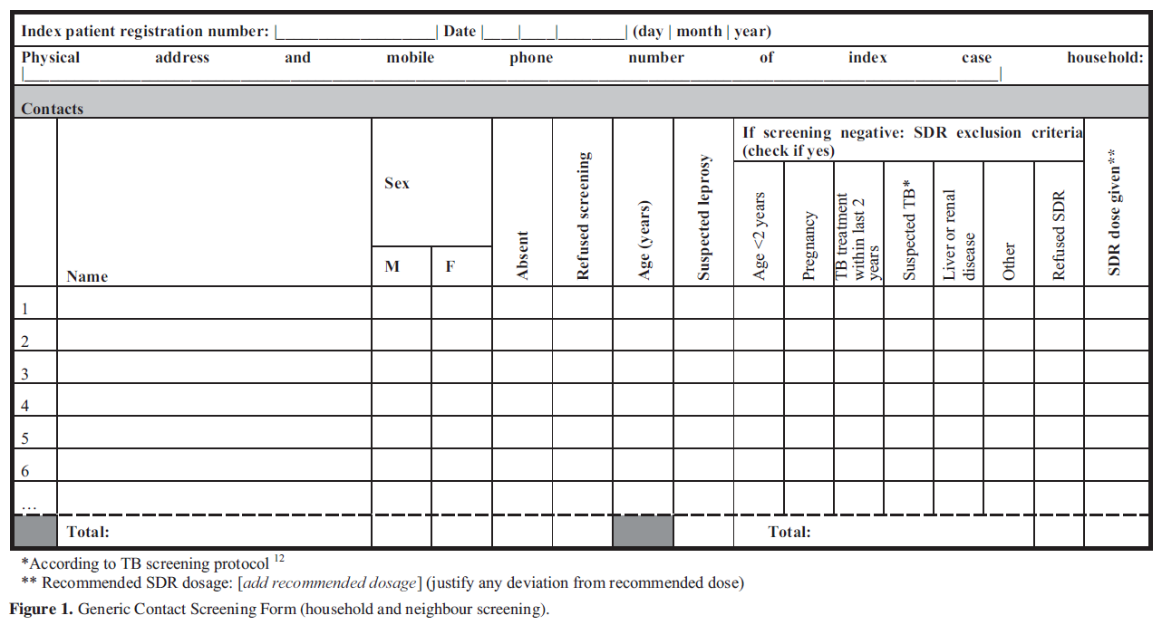
Minimal essential data for community screening [6]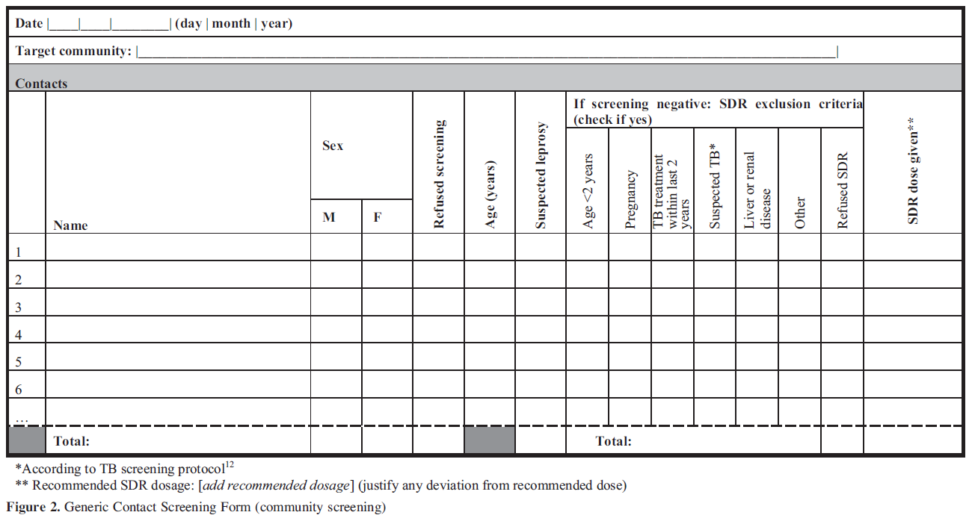

Quality Control and Supervision

Recruitment:
- ____ to supervise ____ to enrol newly diagnosed leprosy patients as new index patient

Enrolment:
- ____ to ensure signed informed consent (if needed) is available for all enrolled index patients

Tracing:
- ____ to ensure properly filled contact lists

Screening:
- ____ to periodically supervise work of ____ (contact screening) (verification of TB and leprosy screening procedures and outcomes)

Referral:
- ____ to ensure return of properly filled referral list leprosy/TB
- ____ to ensure follow-up examination for referred contacts with suspected TB and/or leprosy

SDR administration:
- ____ to periodically supervise work of personnel involved in contact tracing, contact screening and diagnosis of new leprosy patients among the contacts (verification of eligibility assessment and correct dosage)
- ____ to monitor rifampicin drug stocks and usage (in relation to reportedly treated contacts and reported dosage)

Also see 2. Overall roles, responsibilities and timelines.

References
1. Moet, F.J., D. Pahan, L. Oskam, J.H. Richardus, and C.S. Group, Effectiveness of single dose rifampicin in preventing leprosy in close contacts of patients with newly diagnosed leprosy: cluster randomised controlled trial. BMJ, 2008. 336(7647): p. 761-4.
2. WHO, Guidelines for the diagnosis, treatment and prevention of leprosy. http://www.who.int/iris/handle/10665/274127, 2018.
3. Gillini, L., E. Cooreman, T. Wood, V.R. Pemmaraju, and P. Saunderson, Global practices in regard to implementation of preventive measures for leprosy. PLoS Negl Trop Dis, 2017. 11(5): p. e0005399.
4. Barth-Jaeggi, T., P. Steinmann, L. Mieras, W. van Brakel, J.H. Richardus, A. Tiwari, M. Bratschi, A. Cavaliero, B. Vander Plaetse, F. Mirza, et al., Leprosy Post-Exposure Prophylaxis (LPEP) programme: study protocol for evaluating the feasibility and impact on case detection rates of contact tracing and single dose rifampicin. BMJ Open, 2016. 6(11): p. e013633.
5. Steinmann, P., A. Cavaliero, A. Aerts, S. Anand, M. Arif, S.S. Ay, T.M. Aye, T. Barth-Jaeggi, N.L. Banstola, C.M. Bhandari, et al., The Leprosy Post-Exposure Prophylaxis (LPEP) programme: update and interim analysis. Lepr Rev, 2018. 89: p. 102-116.
6. Richardus, J., C. Kasang, L. Mieras, S. Anand, M. Bonenberger, E. Ignotti, T. Barth-Jaeggi, H. Greter, A. Cavaliero, and P. Steinmann, Minimal essential data to document contact tracing and single dose rifampicin (SDR) for leprosy control in routine settings. Lepr Rev, 2018(89): p. 2-12.

